It’s that time of the month to
take a night off from cooking for

St. Vincent’s Family Night!

Wednesday, March 25th – 11am-8pm
(This includes dine-in or carryout)

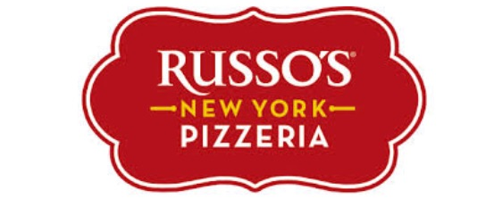
4870 Beechnut Street- Meyerland

Russo’s will donate 20% of the purchases
back to St. Vincent’s!

We will have extra flyers available at the restaurant.

